File system Extenstion Script for RHEL Servers
DEVELOPED BY : V V VINOD KUMAR
TEAM : Unix Team
DATE : 17 AUG 2014

By using the filesystem extension script we will be increasing “/home” filesystem as shown in below outpus.
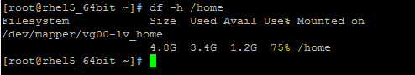
Below is the script file we use for filesystem extension in linux servers.
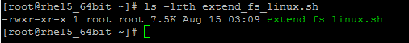
What happens when we run the script as normal user id ?
Below is the warning message displayed when we run the below script as normal user.
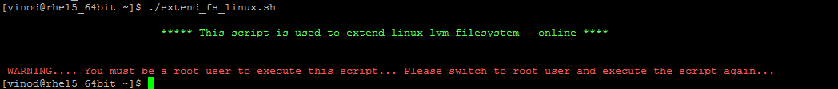
Running the script as root user …..
- We need to enter the filesystem name
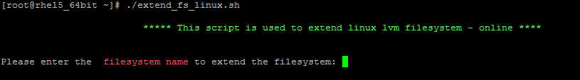

Entered the filesystem name as /home
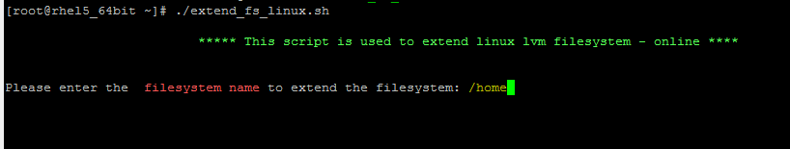
Below are the filesystem details displayed by the script in below format…
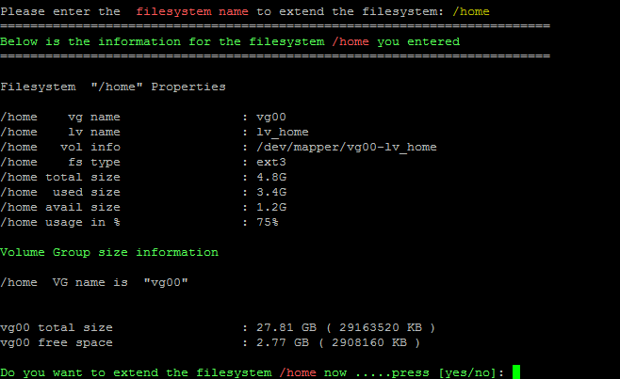
- The script will as for your confimation to extend the filesystem … you can enter yes/no, which are case insensitive (you can enter like yes/YES/yEs/Yes…..same for no option….etc)
- You also need to mention in which size(MB/GB) you enter the data ….. this option is also case insensitive.
- Next the script will ask for the size which is to be extended… and displays the commands before executing. Before executing the commands the script will ask for DOUBLE CONFIRMATION.
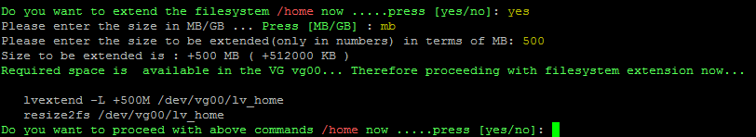
Double confirmation is provided as below to extend the filesystem
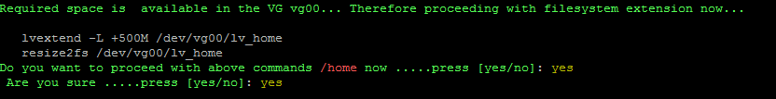
Below is the output displayed after executing after the lvm extension commands.
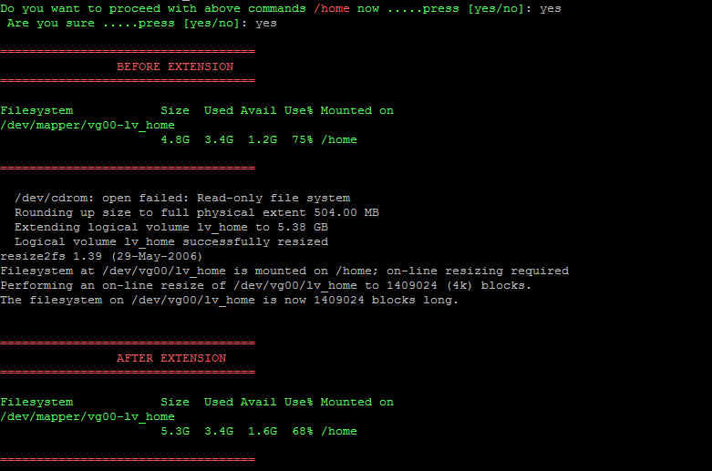

Extending the filesystem by using a new VM disk or by using a new LUN

Before running the script we need to manually scan for the new lun/disk and create a partition using fdisk utility.

Here /dev/sdb is the new vm disk of 1GB added to the server. We need to manually create the partition using /dev/sdb disk using fdisk utility and will provide this disk to the fs extension script as shown below.
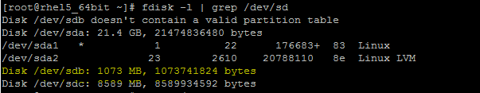
Created partition /dev/sdb1 and labeled the disk as 8e(lvm disk label) ……using fdisk utility.
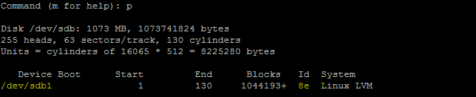

RUN the script to add extend the fs using the new disk in below mentioned steps
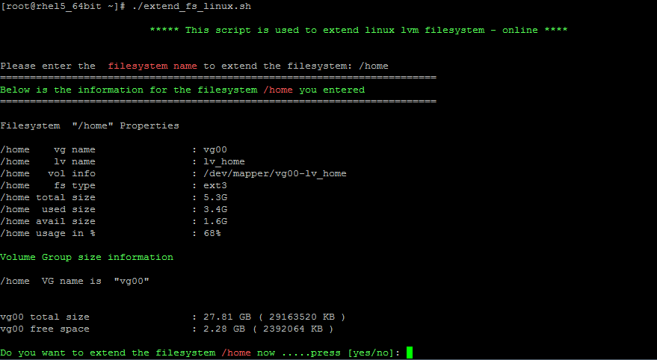
VG free space is not enough to extend the filesystem in below senario, therefore we will provide a 1GB disk to the script.
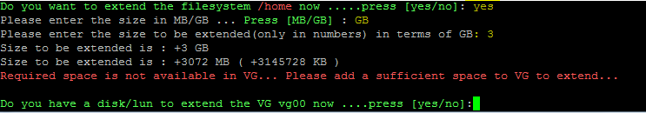
As the vg is not having enough space ….. the script will ask an available disk/lun details as below to add to the volume group.
Below is the disk name provided to the script….
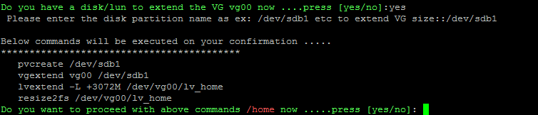
Script will display the list of commands before executing on the server…Confirm twice to proceed with fs extention…
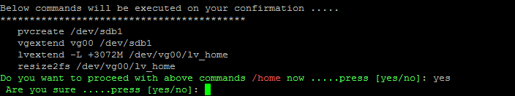
Below is the output…after extending a filesystem using a new disk…..

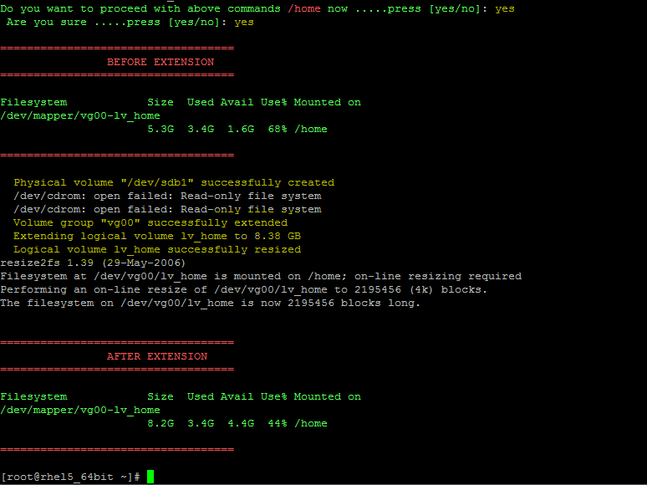

******************BE Happy….Enjoy the day*******************

